Bluejireh Inc.
I-20 Spectrum Analysis
Prepared by Randall Cottrell

Abstract
Rf Spectrum Analysis of section of I-20, downtown Birmingham, AL

www.bluejireh.com
randall@bluejireh.com
205-585-1002
The parameters for our analysis began with location, Time of day, altitude, traffic density of vehicles, scan speed, number of scans, duration of scans and proximity to the underside of the bridge that will be replaced.

Parameters

Location: just over a mile of interstate starting from I 65 and running to 280/31

Time of day: 4:30 PM to 9:00 PM

Altitude: Street level to sixty five feet

Traffic density: very high

Proximity to bridge: within 3 to 8 feet

Speed of scan: 1 mi./h to 15 mi./h

Length of scans: 6-9 minutes

Number of scans per frequency: three

Frequencies scanned: 900 MHz through 999MHz, 2400 MHz through 2499mhz, and 5800 MHz through 5899 MHz

Total scans: nine

Notes regarding location:
Hotels, office buildings, a civic center, restaurants, radio equipment, high voltage lines above, and a large power distribution station directly surround the location. All of the aforementioned buildings or objects are within 100 feet of the interstate.

The analysis began to the west of the Civic Center and continued past the civic center toward highway 280. As we noticed spikes in the reading for 2.4GHz and 900 MHz we notated our location near the Civic Center and Hotel, the FBI building, and the power station.

We noted the announcement of a wireless network possibly being installed by Windstream in downtown Birmingham and the possible existence of high-powered microwave networks already present.

We took note of the many antennas and transmitters on the buildings surrounding the interstate, the access points in the hallway and outside of the hotel and the access points near the uptown entertainment area that runs alongside interstate.

Another fact to consider in the area is the increasing number of cars that are wirelessly enabled in the 2.4GHz range

In addition to our analysis we were also able to speak to a power company lineman who noted the amount of our energy in the air when doing their work.

Lastly, with increasing construction in the area, there will definitely be more possible interference on public use bands like 2.4ghz and 5.8ghz.

Additional notes:
It is important to consider load on the network when planning a network such as this, given the environment.

2.4ghz
In addressing the 2.4 GHz band we found that as we began at waypoint one which is to the East of the civic center, we noticed very high RSSI levels. We believe that as we traveled west and past the civic center, we encountered many signals and the 2.4 GHz band coming from the office buildings and hotels that directly surround the interstate being analyzed. As we neared the end of the Analysis, we noticed a massive spike in energy that actually interfered with our drone. The 2.4 GHz band did have some open channels but there was substantial traffic noticeable on the analyzer, and consequently displayed in the report attached. Please review the 2.4 GHz report for a short summary.

5.8 GHz
In addressing the 5.8GHz band we found that there was not much traffic between waypoint one and waypoint 11. The only caveat is that there is extreme saturation on the 2.4 GHz band and eventually more and more users will shift to the 5.8 GHz band to avoid saturation. While transmission would work fine now for the lighting, looking to the future might prove that the system could encounter increasing interference. Please review the 5.8 GHz report for short summary.

900 MHz
In addressing the 900 MHz band we began with understanding that the product made by echelon operates from 902 megahertz to 928 MHz and we did see a noticeable interferences at times in between 902Mhz and 928MHz. It seems that transmission could be possible given the range available with the echelon products but the type of interference we saw combined with the incredible amount of transmission in the area could signal problems in the future. Please review the 900 MHz report for short summary.

In conclusion, while we cannot and will not recommend a course of action, we have verified via our expertise and outside spectrum analysis experts, several things.

- There is a possibility for steady transmission on the 2.4 GHz network but given the nature of overlapping channels, limited channel availability, extreme spikes, and the volatile and saturated location, there could be substantial cause for concern regarding interference in the long term.
- There’s definite possibility for city transmission on the 5.8 GHz network but the current evolution of wireless dictates that as the 2.4GHz band becomes more saturated, more and more users will shift to the 5.8GHz band to satisfy their wireless connectivity needs. Being that this band is open for anyone to use, we do not feel great confidence in the long-term stability of a permanent install in an area like the one in question.

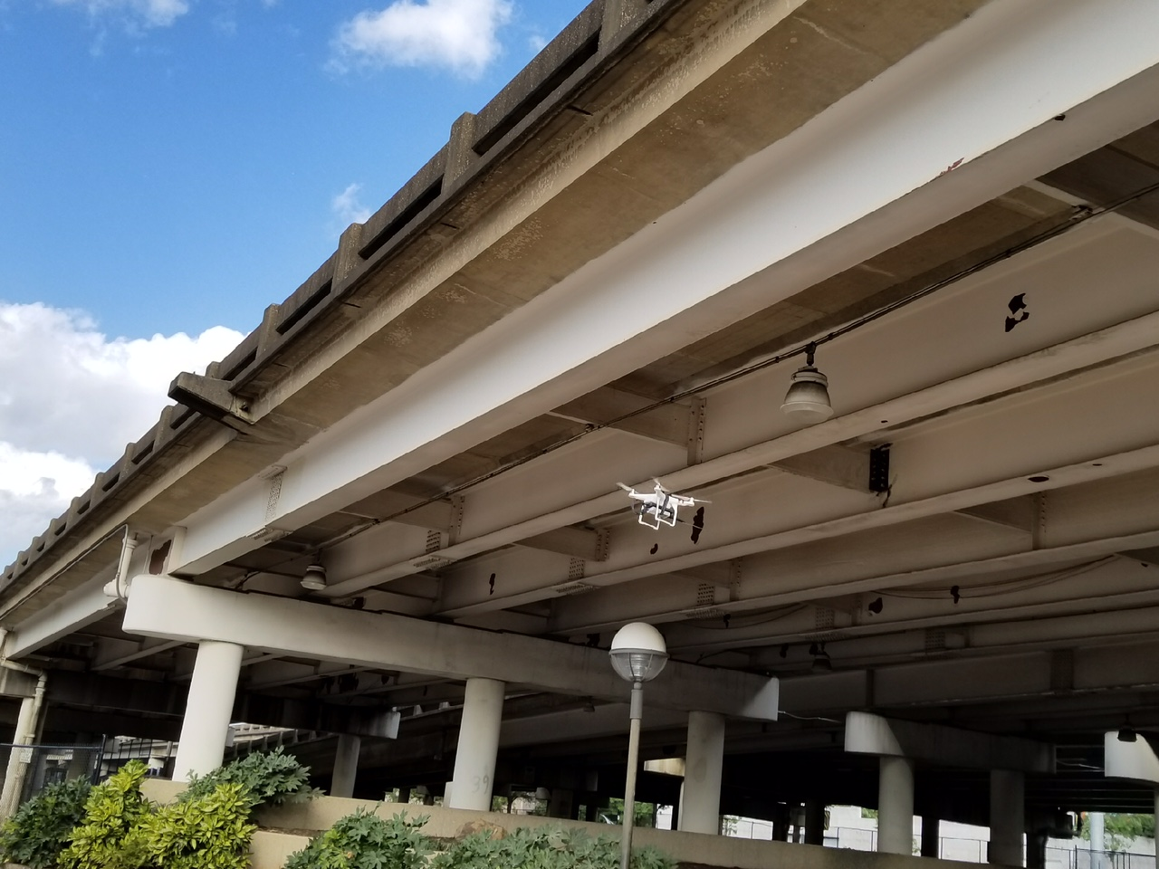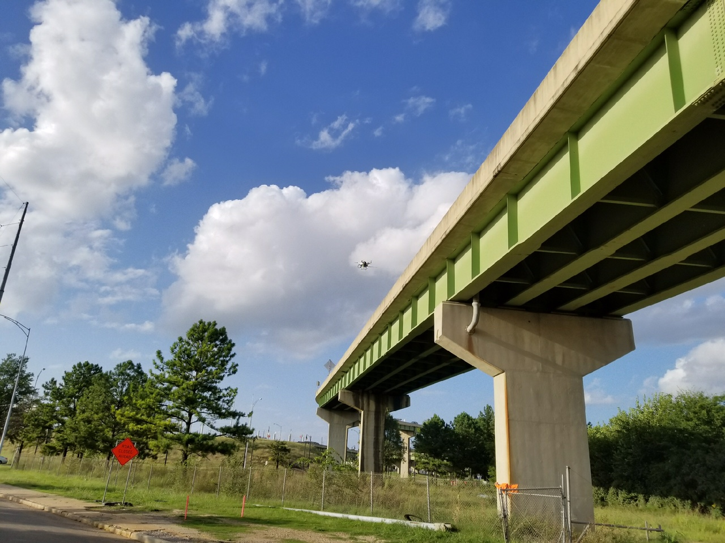

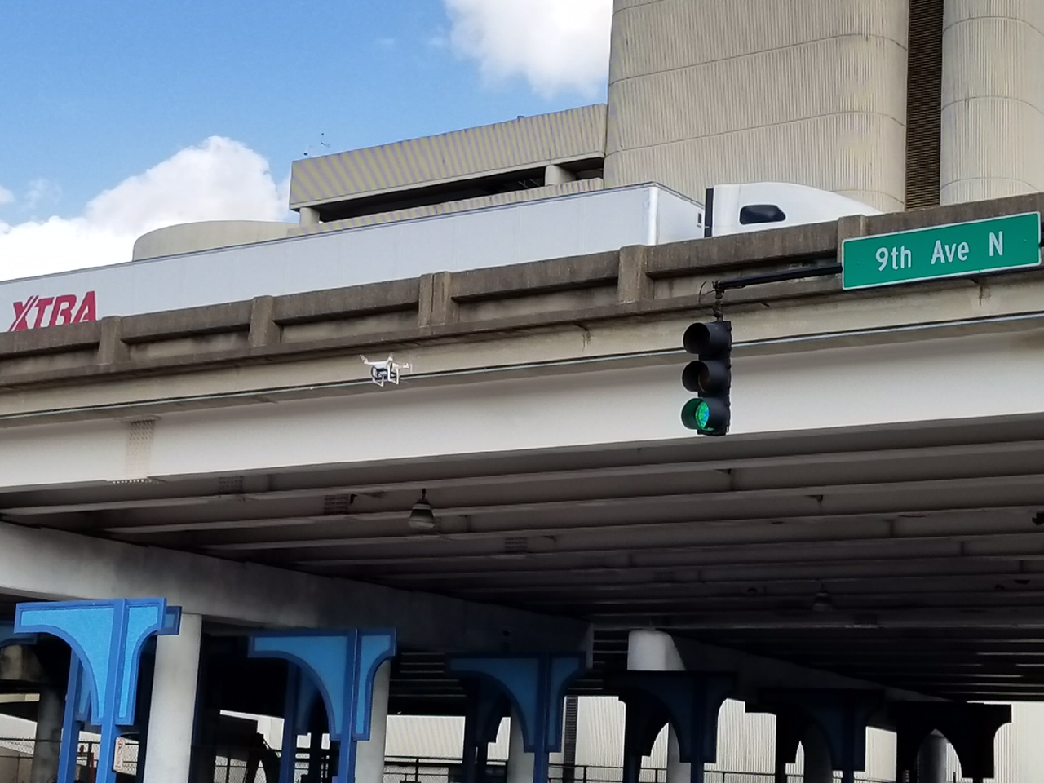

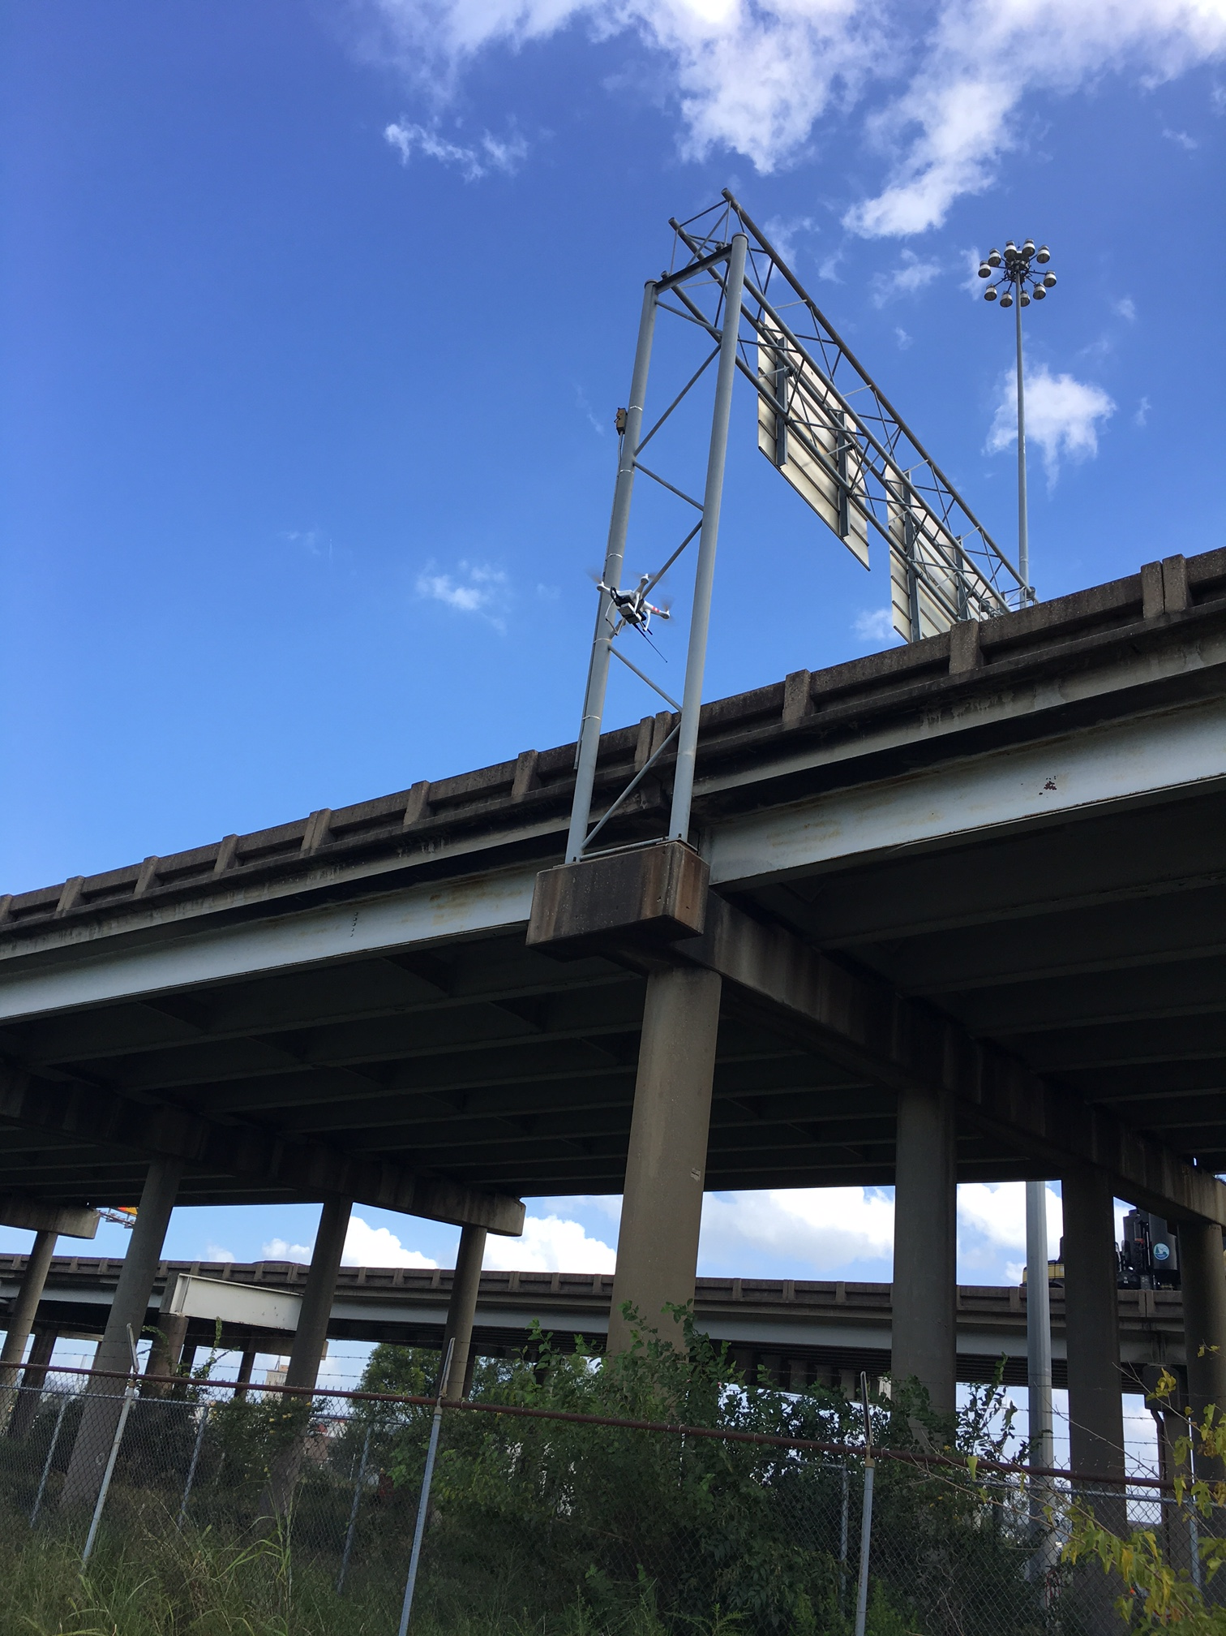

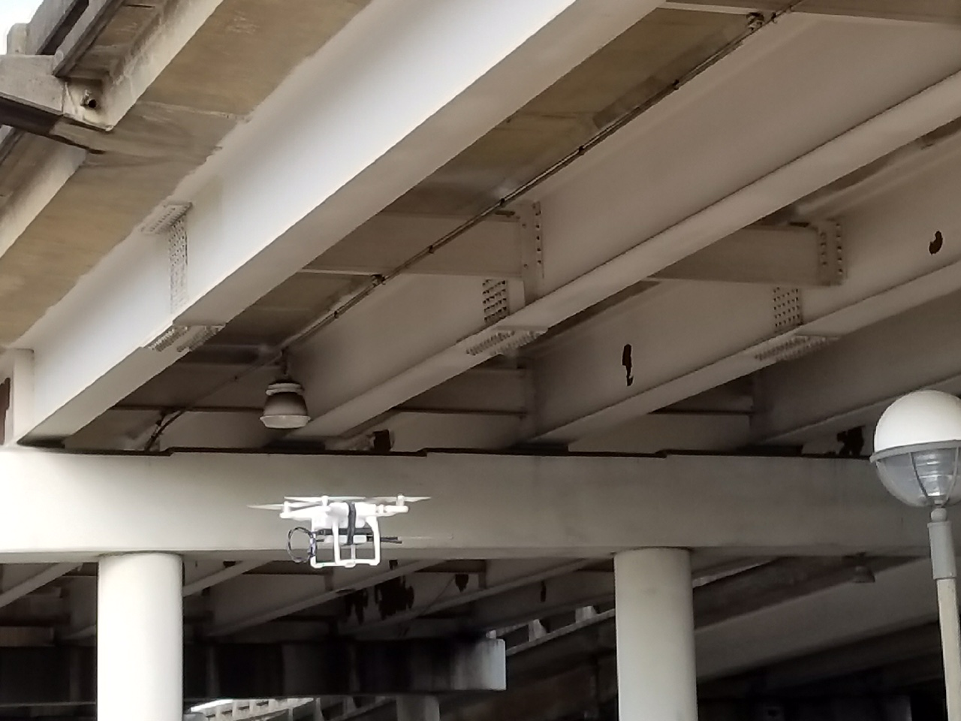

2.4GHz Analysis

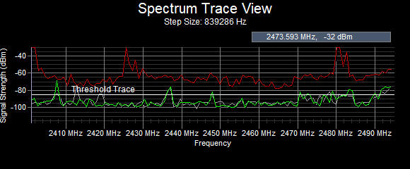

CHANNEL NUMBER | LOWER FREQUENCY  MHZ | CENTER FREQUENCY  MHZ | UPPER FREQUENCY  MHZ
1 | 2401 | 2412 | 2423
2 | 2406 | 2417 | 2428
3 | 2411 | 2422 | 2433
4 | 2416 | 2427 | 2438
5 | 2421 | 2432 | 2443
6 | 2426 | 2437 | 2448
7 | 2431 | 2442 | 2453
8 | 2436 | 2447 | 2458
9 | 2441 | 2452 | 2463
10 | 2446 | 2457 | 2468
11 | 2451 | 2462 | 2473
12 | 2456 | 2467 | 2478
13 | 2461 | 2472 | 2483
14 | 2473 | 2484 | 2495

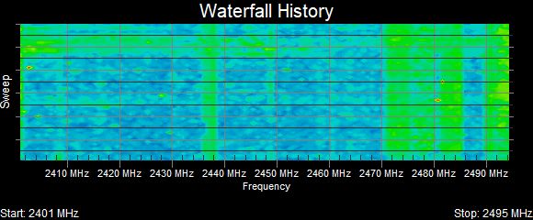

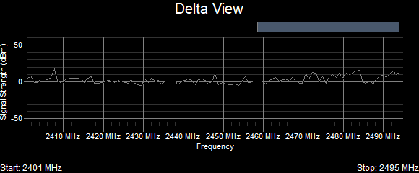
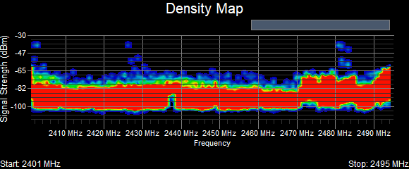

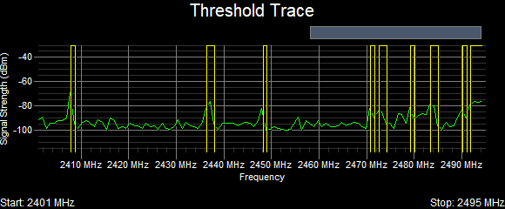

Based on the analysis, we find that the 2.4ghz band is volatile from channels 1-7 and while channel 3, 4, or 9 could be used for transmission, it isn’t best practice operate on channels that are known to overlap when considering long-term stability.

There are noticeable spikes on channels 3, 6/7, and before channel 11 that add to the volatility of the area.

5.8GHz Analysis

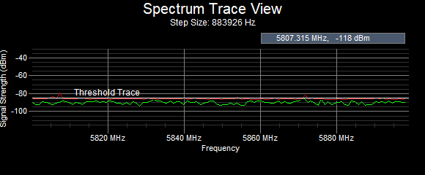

Channel | Frequency Mhz | EIRP
36 | 5180 | 200mw
40 | 5200 | 200mw
42 | 5210 | 200mw
44 | 5220 | 200mw
48 | 5240 | 200mw
50 | 5250 | 200mw
52 | 5260 | 200mw
56 | 5280 | 200mw
58 | 5290 | 200mw
60 | 5300 | 200mw
64 | 5320 | 200mw
149 | 5745 | 1000mw
152 | 5760 | 1000mw
153 | 5765 | 1000mw
157 | 5785 | 4000mw
160 | 5800 | 4000mw
161 | 5805 | 4000mw
165 | 5825 | 4000mw

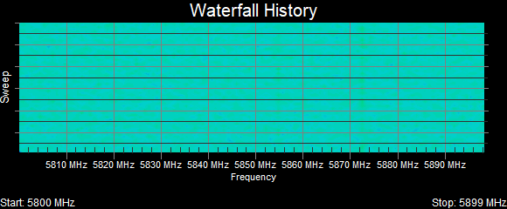

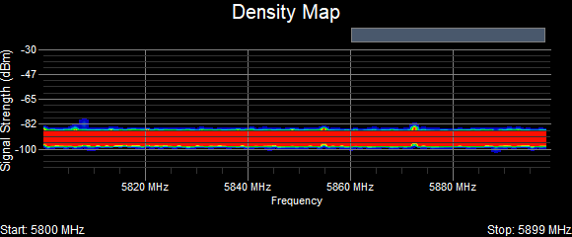

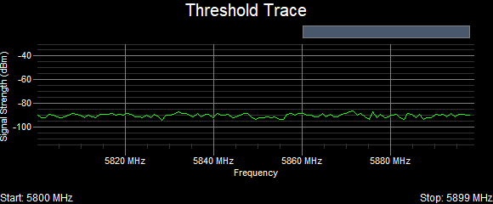

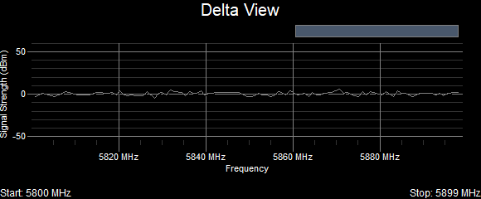

The 5.8ghz band is “clean” meaning there is constant transmission but no major interference picked up by our analyzer. If the system was to be wireless, it would best work on the 5.8ghz band. However, due to the extreme saturation of the 2.4ghz band, it will only be a matter of time before the 5.8ghz band is saturated aswell. That being said, yes the 5.8ghz is usable but may not be the best decision long-term
900Mhz Analysis

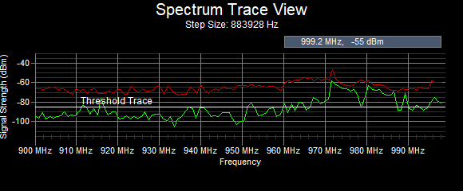

- Echelon Operating Frequency: 902—928 MHz
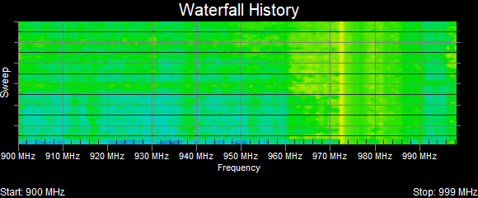

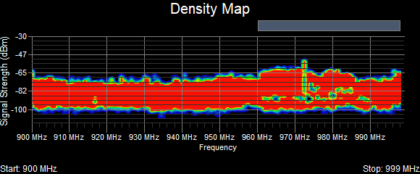
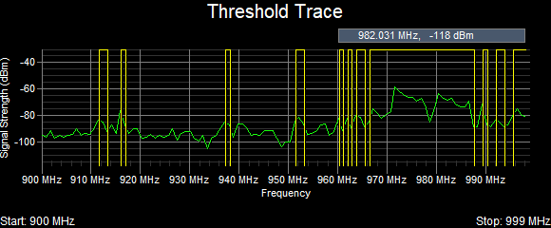
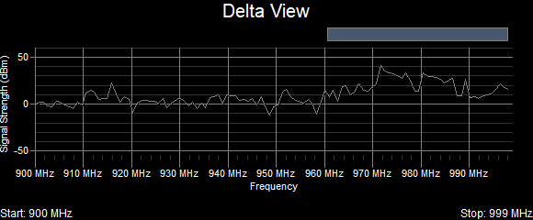
- Echelon Operating Frequency: 902—928 MHz
The 900mhz band was for the most part “clean” except for some substantial noise that could cause interference between 912mhz and 916-918mhz. The Echelon products could transmit but may encounter some interference.

